Project Information Report - Godrej Parkshire

Project Summary
Sales Status: Sustenance
Construction Status: Under Construction, Foundation Stage

Configurations (all of them) & Pricing (in crs.)
Configuration | Saleable Area/SBU Size (sq. ft.) | Agreement Value (Starting Price) | Pricing Range  (Agreement Value + GST) | Pricing Range (Agreement Value + GST + SDR)
2BHK Luxe | 1224-1228 sq. ft. | 1.35 Cr. | 1.35 Cr. + 5 % | 1.35 Cr. + 5 % + 7.7%
3 BHK  Premium | 1615-1634 sq. ft. | 1.75 Cr. | 1.75 Cr. + 5 % | 1.75 Cr. + 5 % + 7.7%
3 BHK Luxe | 1750-1803 sq. ft. | 1.95 Cr. | 1.95 Cr. + 5 % | 1.95 Cr. + 5 % + 7.7%

RERA: Possession & OC Timelines
  - RERA Number: PRM/KA/RERA/1250/304/PR/090126/008393

RERA Certificate Link:
https://rera.karnataka.gov.in/certificate?CER_NO=PRM/KA/RERA/1250/304/PR/090126/008393
  - Possession Timeline As Per RERA (Month and Year): 12/2030
  - Possession Timeline Target As Per GPL (Month and Year):12/2029

Freedom Payment Plan
- Payment Plan - 20:20:60 freedom Payment Plan
- How it will work for this project (with demo illustration of the calculation):

2 BHK Luxe Sample Calculation

Total Cost for Customer 1,44,81,191.80
Total Agreement Value 1,35,09,521

Milestone - 20:20:60 Payment Plan | % | 2BHK Luxe - 1223 sqft | Logic
Booking Amount | 5% | 7,09,249.85 | 5% Of Agreement Value +  additional 5% GST of that value
Within 21 days of Booking | 5% | 7,09,249.85 | 5% Of Agreement Value +  additional 5% GST of that value
Within 60 days of Booking | 10% | 14,18,499.70 | 10% Of Agreement Value +  additional 5% GST of that value
On Completion of Terrace | 20% | 28,36,999.41 | 20% Of Agreement Value +  additional 5% GST of that value
On Completion of Flooring in the Purchaser’s Apartment/Unit | 40% | 56,73,998.82 | 40% Of Agreement Value +  additional 5% GST of that value
On Receipt of Occupancy Certificate | 10% | 14,18,499.70 | 10% Of Agreement Value +  additional 5% GST of that value
On Notice of Possession | 10% | 14,18,499.70 | 10% Of Agreement Value +  additional 5% GST of that value
On Notice of Possession: Advance Maintenance & Sinking Fund Charges | 0% | 2,94,121.47 | Advanced Maintenance & Sinking Fund Charges + 18% GST of Advanced Maintenance Value
Total Cost | 100% | 1,44,81,191.80

Additional SDR Charges (changes during handover from year to year; starting from 7%) at the time of possession
* This illustration is for representation purposes only. The actual calculation and monthly payout may vary depending on the (i) unit selected (ii) associated charges for that unit and (iii)
the offers available at project marketing office.

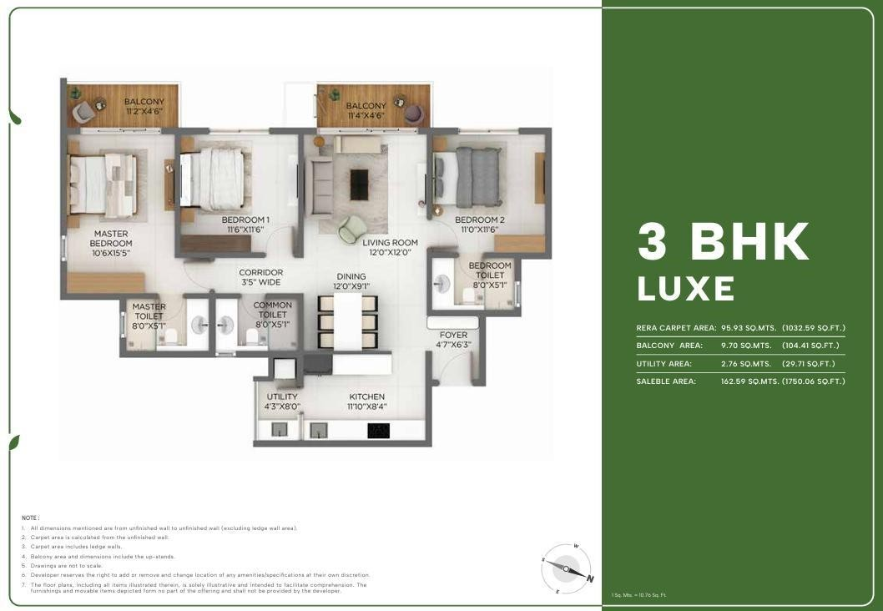
Floor Plans

Digital Collaterals - Godrej Parkshire, Bangalore

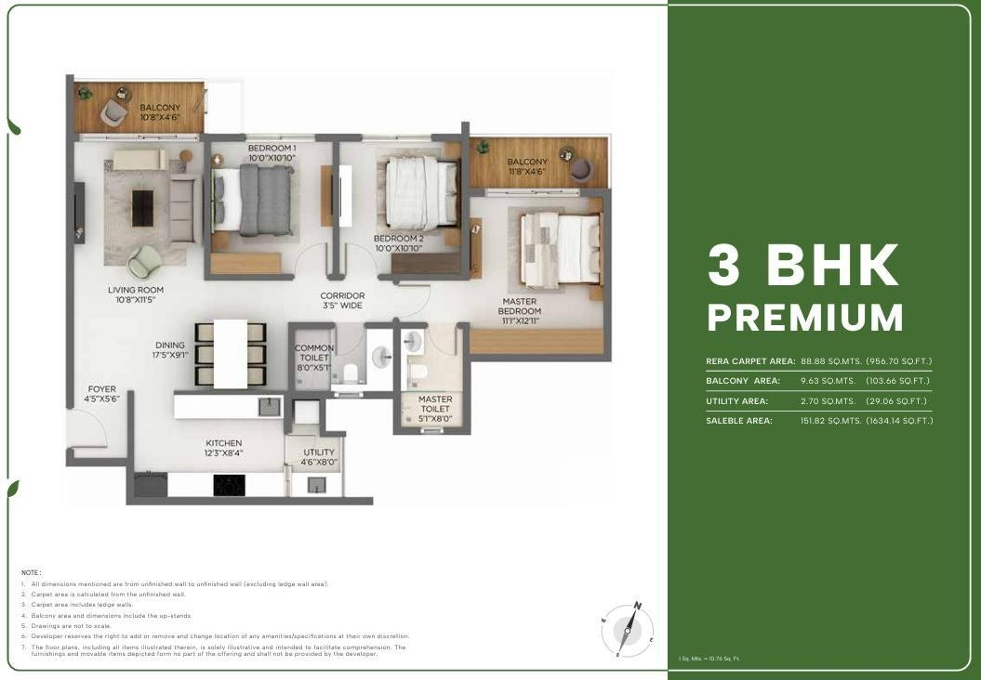
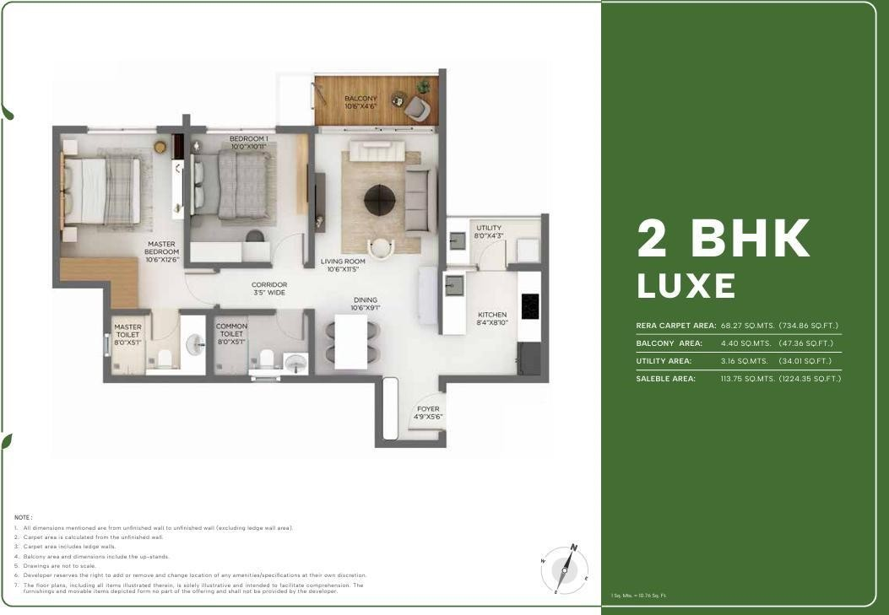

Location Advantages

🚗 Connectivity
  - Old Madras Road – 7 mins*
  - Hoskote Industrial Area – 16 mins*
  - Hope Farm Junction – 20 mins*
  - Whitefield Main Road – 22 mins*
  - KIADB Aerospace Park – 35 mins*

🚉 Commute & Transport
  - Satellite Town Ring Road (STRR) – 10 mins*
  - Whitefield Metro Station (Namma Metro) – 22 mins*
  - Whitefield Railway Station – 22 mins*
  - Kempegowda International Airport – 40 mins*

🛍️ Recreational & Lifestyle Hubs
  - Orion Uptown Mall – 12 mins*
  - Decathlon OMR – 16 mins*
  - INOX SBR Horizon – 18 mins*
  - Vivanta Bengaluru Whitefield – 24 mins*
  - Nexus Shantiniketan Mall – 28 mins*
  - Phoenix Marketcity – 28 mins*

💼 Tech Parks & Employment Hubs
  - Bearys Global Research Triangle – 15 mins*
  - Brigade Signature Towers – 16 mins*
  - International Tech Park Bangalore – 24 mins*
  - ITPL – 25 mins*
  - RMZ Infinity – 28 mins*
  - Bagmane World Technology Centre – 30 mins*
  - EPIP Zone – 30 mins*

➵ Schools & Colleges
- Delhi Public School – 8 mins*
- Winmore Academy – 9 mins*
- The Polaris International School – 10 mins*
- One World International School – 14 mins*
- New Baldwin School – 20mins*
- MVJ Engineering College – 18 mins*
- National Public School – 22 mins*
- Orchids International School – 30 mins
- VIBGYOR High School- 20min*
- Jain Heritage School- 20mins*

🏥 Healthcare Facilities
  - Siliconcity Hospital – 7 mins*

MVJ Medical College & Research Hospital – 10 mins*
  - Sathya Sai Orthopedic & Multispecialty Hospital – 16 mins*
  - East Point Hospital – 20 mins*
  - Manipal Hospital Whitefield – 24 mins*
  - Vydehi Hospital – 24 mins*
  - Aster Whitefield Hospital – 24 mins*

Micro Marketing Understanding
📍 Market Overview
Hoskote is emerging as a high-potential residential corridor in East Bangalore, driven by its strategic location between Whitefield and key industrial zones. Traditionally known as an industrial hub, Hoskote is now witnessing a shift towards organized residential development, making it attractive for both end-users and long-term investors.

📈 Growth Story
The growth of Hoskote is anchored on three key pillars:

- Whitefield Spillover Effect

With Whitefield reaching saturation in terms of pricing and density:
  - Buyers are moving outward in search of affordable alternatives
  - Hoskote offers significantly lower entry prices
  - Travel time remains within 20–25 minutes, making it a viable residential option

👉 This creates a strong end-user demand pipeline

Industrial & Employment Backbone

Hoskote is not just a residential extension—it has a self-sustaining economic base:
  - Presence of Hoskote Industrial Area
  - Proximity to KIADB zones and logistics hubs
  - Growing warehousing and manufacturing activity

👉 This ensures consistent rental demand and workforce-driven housing needs

- Infrastructure-Led Appreciation

Upcoming and existing infrastructure is a major catalyst:

  - Satellite Town Ring Road (STRR) improving regional connectivity
  - Access to Old Madras Road (NH 75)
  - Connectivity to Namma Metro via Whitefield
  - Improved access to Kempegowda International Airport

👉 Infrastructure expansion is expected to unlock land value appreciation over the next 5–10 years

💰 Price Positioning Advantage
  - Hoskote is currently 30–40% more affordable than core Whitefield

Offers larger homes at lower ticket sizes
  - Ideal for first-time homebuyers and budget-conscious IT professionals

👉 Positioned as:
“Early-entry market with future upside potential”

👥 Buyer Profile
  - First-time homebuyers
  - Salaried professionals working in Whitefield / ITPL
  - Industrial workforce (mid-management & above)
  - Long-term investors looking for appreciation

🏗️ Developer Activity & Market Maturity
  - Increasing entry of branded developers like Godrej Properties
  - Shift from plotted developments to integrated apartment communities
  - Gradual improvement in social infrastructure (schools, hospitals, retail)

👉 Indicates transition from “emerging” to “establishing” micro-market

⚖️ Competitive Landscape

Compared to Whitefield:

- Lower price
- Slightly longer commute
- Higher appreciation potential

Compared to Budigere / Old Madras Road belt:

- More industrial demand
- Better price entry
- Faster land absorption

FAQs Used By Sales & Pre-Sales Teams

General Project FAQs

  - Where exactly is the project located?

Godrej Parkshire is in Hoskote, East Bangalore, next to NH-648, offering easy access to major IT hubs.

  - Who is the developer?

The project is developed by Godrej Properties, one of India’s most trusted real estate brands.

  - Is the project RERA approved?

Yes

  - What is the possession timeline?

December 2030

  - What configurations are available?

2BHK and 3BHK

Pricing & Costing FAQs

  - What is the starting price?

1.35cr on wards

- What are the additional charges?

GST, PLC, FRC, AM, SDR

Are there any hidden costs?

No there are no hidden charges

20:20:60 Freedom Payment Plan FAQs

- What is the 20:20:60 Freedom payment plan?

20:20:60 Freedom Payment Plan—pay just 20% now, 20% later and the remaining 60% on possession.

- Does the 20:20:60 freedom payment plan include GST and registration?

20:20:60 payment plan yes its include GST and Exclude Registration.

- How much do I need to pay upfront?

10 percent of property value.

- When does the home loan EMI start?

After 10 percent of initial payment home loan can start.

- Can I prepay or exit the 20:20:60 Freedom payment plan?

No

Location & Connectivity FAQs

- How far is Whitefield?

20 min* from whitefield

- Is metro connectivity available?

Yes, its available

- How far is the airport?

50 min* from airport

Investment & Decision-Making FAQs

- Is this a good investment?

Yes, due to:

- Rapid infrastructure growth in East Bangalore
- Proximity to IT corridors
- Upcoming metro expansion

- Who is this project ideal for?

- First-time homebuyers
- IT professionals working in Whitefield
- Long-term investors

Construction & Quality FAQs

- What is the current construction status?

Under Construction, Foundation

Conflict Handling FAQs

- Why should I buy in Hoskote instead of Whitefield?

You get larger homes at lower prices with future appreciation potential, while still being close to Whitefield.

- Isn’t Hoskote too far or underdeveloped?

Not anymore—Hoskote is seeing rapid infrastructure growth, highways, and planned metro connectivity.

Because of:

- Trusted brand (Godrej Properties)
- Better construction quality
- Modern amenities & community living

- Why is this priced higher than nearby local builders?

- What if the project gets delayed?

Being a reputed developer, delays are rare—and RERA ensures accountability and compensation clauses.

- Is the 20:20:60 freedom payment plan really beneficial?

Yes, it reduces financial burden during construction and improves cash flow flexibility.

Closing-Oriented FAQs

- What is the best unit available now?

Premium-facing units (park view / corner units) are currently in high demand and offer better long-term value.

- Are there any current offers?

20:20:60 freedom payment plan

- How do I block a unit?

Token amount of 5 percent

Legal Disclaimers

PRM/KA/RERA/1250/304/PR/090126/008393, available at website: http://rera.karnataka.gov.in. Site Address: Godrej Parkshire, SY NO 36/1, 36/2, 36/3, 36/4A1, 36/4A2, 36/4B1, 36/4B2, 36/5, 36/6, 36/7, 36/8, 36/9, 66/1, 66/2, 66/3, 67/1A1, 67/1A2, 67/1A3, 67/1B1, 67/1B2, 67/1B3 67/2, 67/3, 67/4, 68/1, 68/2, 68/3, 68/4 AND 68/5 Sarkariguttahalli Village, Kasaba Hobli, Hosakote, Bengaluru Rural, Karnataka - 562114. The project is registered as Godrej Parkshire.

The images contains artist's impressions. No warranty is expressly or impliedly given that the completed development will comply in any degree with such artist's impression as depicted. The furniture, accessories, paintings, plantations, landscaping, items, electronic goods, additional fittings/fixtures, decorative items, false ceiling including finishing materials, specifications, shades, sizes and colour of the tiles, etc. shown in the image are only indicative in nature and are only for the purpose of illustrating/indicating a conceived layout and do not form part of the standard specifications/amenities/services to be provided in the unit and/or the Project. The Sale is subject to terms of Application Form and Agreement for Sale. All specifications of the unit shall be as per the final agreement between the Parties.*The prices mentioned are an indicative Agreement Value. Stamp Duty Registration, GST and Other Charges over and above the Agreement Value. Customers are advised to apprise themselves of the necessary and relevant information of the project prior to making any purchase decisions. The official website of Godrej Properties Ltd. is www.godrejproperties.com. Please do not rely on the information provided on any other website. T&C Apply*

